Caring about Care
Improving the experience of care for people with dementia in hospital
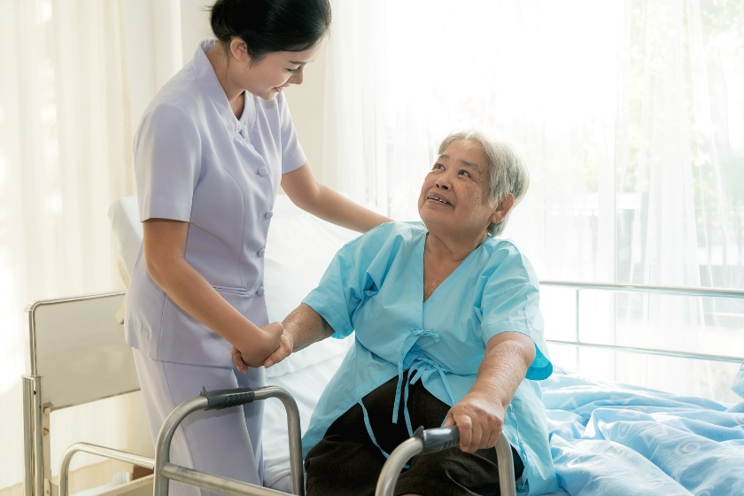

This document is our plain language protocol summary (PLPS). A protocol is like a map that explains how researchers intend to achieve their aims for an upcoming project. The PLPS helps anyone interested in this project to understand the process of research without all the detail normally included in published protocols.

Where will this information be available?
This plain language protocol summary (PLPS) will sit with the published academic protocol on our website (http://clahrc-peninsula.nihr.ac.uk/research/caring-about-care), on the NIHR website (https://www.journalslibrary.nihr.ac.uk/programmes/hsdr/165252/#/), on PROSPERO (https://www.crd.york.ac.uk/PROSPERO/display_record.php?RecordID=86013), and will be a document for team members with a non-research background to refer to throughout the project.

What is this research about?
Hospital services are geared towards fast and effective responses: assessment, diagnosis, intervention and discharge. Services run on the assumption that patients will be able to express their wishes, acknowledge the needs of other patients, and move through the system as required.
However, for people with dementia, particularly when they are ill or have had an accident, hospital settings can be confusing, challenging and overwhelming. This can further impact their well-being and the ability to optimise their care. Furthermore, what happens in hospitals can have a profound and permanent effect on individuals and their families – not only in terms of their inpatient experience – but also their ongoing health, and the decisions that are made about their future.

What are we trying to find out?
1. What are the experiences of care for people with dementia in hospital, their families and the staff caring for them?
2. What changes to healthcare services in hospital will best improve these experiences of care?
We will answer these questions by combining findings from existing studies – this is called a systematic review. We then want to use this information to improve hospital care. Working alongside the people who will use this research is important throughout the Caring about Care study, but it is particularly important during the final stage of the research, when the findings will be widely shared. We want to work together with the people who will use this research to understand and communicate the findings in a form that is accessible and meaningful.

What is involved in doing a systematic review?
Combining the findings from all existing studies is called ‘systematic review’. It is ‘systematic’ because:
- It will include all information about the chosen topic, not just information individuals think important;
- The quality of the studies is assessed;
- It is reported clearly enough so that someone else would be able to conduct the review in the same way.
We expect to find studies in which researchers have interviewed health care professionals, people with dementia and their carers about their experiences of being in hospital (qualitative research) and studies in which the effects of efforts to improve the experience of care in hospital for people with dementia have been measured (quantitative research).

How will we do the systematic review?
We’ve included a list of the full team on Page 5 of this document. The day to day review tasks will be completed by Ruth, Hannah, Becca, Morwenna and Jo. They will meet weekly to discuss progress. Researchers with expertise in statistics (Sue), health economics (Colin), qualitative research (Darren), nursing (Dave) and dementia (Linda, David and Iain) and clinicians with experience of caring for people with dementia in hospital (Colm, Debbie and Anthony) will join those meetings when there are specific issues to discuss and will also be available to provide advice by email. We also have the benefit of an Expert Advisory Group with experience in many other aspects of dementia care. We will meet with the Expert Advisory Group on four occasions during the project.
The different stages of a systematic review are shown in Figure 1. In the following sections we describe each stage and what we hope it will achieve. We also highlight where the people in the team with real-world experience of these issues can help.

How did we come up with the question?
The idea for the Caring about Care project started at a South West Network Meeting for Alzheimer's Research UK. Researchers, practitioners and carers talked about what was needed most to improve things for people with dementia. The questions they came up with formed the foundation for this study. A number of people from that group went on to recruit others to complete gaps in expertise, forming an Expert Advisory Group (EAG) that includes former carers, healthcare practitioners, care home staff and researchers with methodological and dementia expertise. Together they designed the research project detailed below. The group successfully applied for funding from the Health Service and Delivery Research Programme of the National Institute of Health Research, which was granted in 2017.

The protocol
A protocol acts as a map that researchers write before they begin a project that then guides their work. Our draft protocol was shared at the first Whole Team Meeting held in February 2018 for comments. The final protocol can be found here.

Figure 1. The process of doing a systematic review.

Full search
From our background reading, and by asking for ideas during our first Whole Team Meeting, our Information Specialist (Morwenna) will compile terms that relate to dementia, hospital settings, and the experience of care. Morwenna will then run a search of academic databases to identify studies that include these terms in their titles and abstracts. We will also look for research referred to in the studies we have already found, and ask the experts in Dementia on our team about any research we have missed.

Title and abstract screening
The full search will return a list of titles and abstracts that are potentially relevant to the review. Ruth, Hannah, Morwenna and Becca (and any members of the wider team who want to be involved), will screen each title and abstract found during the full search to decide if it is relevant or not. Two different people will screen each entry, make a decision, and then compare answers. If they disagree, they will discuss their decisions and will ask another member of the team (Becca or Jo) to help if necessary.

Full text screening
Because titles and abstracts don’t include all the relevant information about a study – they just give a brief overview – we will need to find the full publication for all the papers that look like they might be useful. The same process as for title and abstract screening is repeated at full text screening – two people make a decision about whether a paper should be included or not in the review, then compare answers. Where they disagree they discuss why or why not the study should be included to make a decision. If they can’t agree, they will ask Becca or Jo to help.

Data extraction
‘Data extraction’ refers to the process of compiling all the information from each included study that is relevant to the review. Ruth and Hannah will do this part of the review. Using tables, the same information – for example, the process of recruiting participants, the characteristics of participants, methods of data collection and analysis, and findings – is recorded for each study. This makes it easier to compare studies and to see similarities and differences, as well as making it more straightforward to find information. It is also part of what makes the review ‘systematic’ – information is drawn from each study using the same process.

Critical appraisal
‘Critical appraisal’ is a process of evaluating how robust each included study is by looking at how the researchers designed and conducted their study. Ruth and Hannah will complete this phase. We will use checklists that have been accepted as sound by other systematic reviewers. Critical appraisal helps us to make judgements about the quality of each study so that we can prioritise the findings from the best studies.

Synthesis
Synthesis is the process of combining the findings from all the studies. For studies that look at whether efforts to improve the experience of care work or not (quantitative studies), the results will be described and compared, and if possible, combined, to show what kind of changes to hospital practice improve experiences of care. For studies in which researchers have interviewed health care professionals, people with dementia and their carers about their experiences of being in hospital (qualitative studies), the findings will be described and compared, and where possible, new ideas about how and why the experience of care is improved will be developed.
The input of people with real world experience of the challenges for people with dementia of being in hospital is valuable during this stage of a systematic review for helping researchers to interpret findings. First-hand knowledge of hospital practice and the experience of living with and caring for people with dementia can inform findings that may have become removed from the realities and complexities of everyday life. We have planned a Whole Team Meeting for the early part of this stage, so that we can discuss, and make sense of, the emerging findings.

Update search
About six months before the end of the study, Morwenna will run an update search to find out if any new research has been published since we conducted the first full search. The search results will be screened in the same way as before, and any new relevant studies will be added to the review.

Communicating findings
This final phase of the Caring about Care project is a particularly important one, because we are trying a more collaborative approach to communicate our findings. Drawing from contacts across the whole team, we plan to hold multiple events across England, where we will discuss how best to change hospital practice.
We will seek people currently involved with hospital care for people with dementia – hospital staff, charitable organisations, carers and people with dementia themselves – to ask how our findings could be used. Together we will create plans for service change that will be shared across healthcare and dementia-support networks.

How to get in touch and find out more:
Weblink: http://clahrc-peninsula.nihr.ac.uk/research/caring-about-care
Email addresses
Ruth Gwernan-Jones: R.C.Gwernan-Jones@Exeter.ac.uk
Hannah Jones: H.Jones4@Exeter.ac.uk

The Caring about Care team

Day-to-day research tasks
Jo Thompson-Coon - Principal Investigator
Rebecca Abbott - Senior Research Fellow
Hannah Jones - Research Fellow
Ruth Gwernan-Jones - Research Fellow
Morwenna Rogers - Information Specialist

Additional expertise
Darren Moore - qualitative research.
Iain Lang – dementia research and implementation.
David Llewellyn - dementia research; David is also a primary carer of a person with dementia.
Linda Clare – dementia research.
Sue Ball – statistics.
Colin Green – health economics.
Dave Richards – nursing and complex interventions.
Anthony Helmsley. Consultant geriatrician.
Colm Owens. Consultant old age psychiatrist.
Debbie Cheeseman. Consultant nurse for older people.

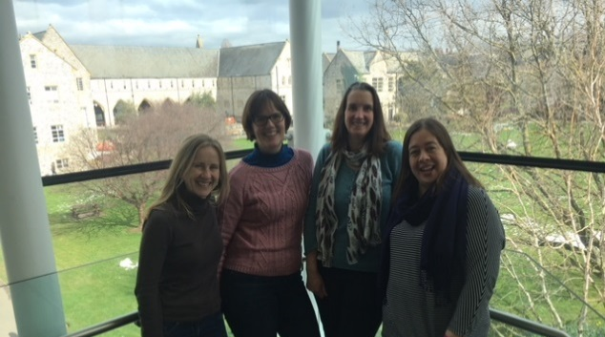
The Caring about Care team members who conduct day-to-day research tasks: Becca, Ruth, Morwenna and Jo

Expert Advisory Group
Sue Lawrence - experience of caring for someone with dementia; member of the Alzheimer’s Society Research Network.
Julia Burton - experience of caring for someone with dementia; member of the Alzheimer’s Society Research Network.
Chrissy Hussey - Consultant Admiral Nurse Dementia Lead from HospiceCare.
Dominic Hudson – Commissioning Manager, Northern, Eastern & Western Devon Clinical Commissioning Group.
Di Walker - Consultant nurse from Northern Devon Healthcare NHS Trust.
Martyn Rogers – Chief Executive AgeUK Exeter, a charity providing support to people with dementia and their carers.
George Coxon - care home owner and founder of Devon Care Kitemark.
Sarah Black – Head of Research, South West Ambulance Service Foundation Trust.
Jo Gajtkowska – Programme Manager (Improvement), South West Academic Health Science Network.

