Modelling the Exeter memory clinic assessment pathway and the impact of the DECODE triage system

Background
The DECODE app has been developed by Dr David Llewellyn at The University of Exeter. The triage system screens patients for dementia and provides a probability of their having dementia. Those patients who are most unlikely to have dementia can be referred back to the GP without the need to undergo an assessment. PenCHORD were approached to model the impact of implementing the triage app in the Exeter memory clinic and how it would affect waiting times for assessments.

The model
The first stage of the modelling process was to create a process map of the Exeter memory clinic assessment pathway. From the process map a conceptual model was created and data could be requested to populate the actual model. The data used to parameterise the model was individual patient episode data from December 2014 to November 2016 inclusive. The model structure is a simplified version of the assessment pathway; referrals for assessment arrive at the rate ascribed by the data, patients then wait for an assessment and then based on the prevalence of dementia seen at the clinic patients have one of five outcomes and exit the system.
This model is a simplification of the Exeter memory clinic assessment system and as such assumes 9 assessment slots per week every week. The actual number of possible referral slots is 16 however, the patient referral rate for the Exeter memory clinic did not produce as queue as empirically observed. Analysis of the data showed that on average 12.4 slots (SD 3.5) were provided over 2015 and 2016. Through discussions with the collaborators it became apparent that due to holiday, sickness and other pressures Exeter memory clinic often is not able to provide 16 assessments slots per week. Nine assessment slots per week enabled a queue to form at a rate approximate to that observed in the memory clinic data. The simulation runs had a warm-up period of 1000 days to ensure that 150 people were in the queue for assessment and it then ran for 2 years to enable the trends in the data to be captured.

Results
The simulation scenarios were run with the DECODE triage process set with a dementia prevalence of 40%. Nine scenarios were run in the model for cut-off point probabilities of 0.1 to 0.5 in steps of 0.05. The scenario numbers, cut-off points and test sensitivity and specificity values are given in table 1 below. Each scenario was run 188 times in a trial to ensure 95% confidence in the ability of the model to account for the variance across the parameters of: Average queue size, average queuing time, resource utilisation and the time taken for the queue to reach a zero queue size.

Table 1 Cut-off point scenarios tested in the model
 |  | Sensitivity |  | Specificity
Scenario | Cut point | Correct | Error | Correct | Error
1 | 0.1 | 98.68 | 1.32 | 75.92 | 24.08
2 | 0.15 | 97.35 | 2.65 | 80.15 | 19.85
3 | 0.2 | 96.03 | 3.97 | 82.54 | 17.46
4 | 0.25 | 95.7 | 4.3 | 84.56 | 15.44
5 | 0.3 | 95.03 | 4.97 | 83.4 | 16.6
6 | 0.35 | 95.03 | 4.97 | 87.68 | 12.32
7 | 0.4 | 94.7 | 5.3 | 89.34 | 10.66
8 | 0.45 | 94.37 | 5.63 | 89.89 | 10.11
9 | 0.5 | 93.38 | 6.62 | 90.44 | 9.56

Waiting times
The graph on the left in Figure 1 shows that in the baseline scenario where there is no DECODE triage that the waiting time for assessment continues to steadily increase over time. The right hand graph of the experimental scenario with the DECODE triage app shows a different trend. Consistently across all nine scenarios the waiting time continued to increase for 43 working days (61 consecutive days) after the introduction of the DECODE triage system. At 43 days the trend reverses and waiting times begin to decrease until between 142 and 187 working days (198 and 261 consecutive days) where you reach a level of less than a 1 day wait time.

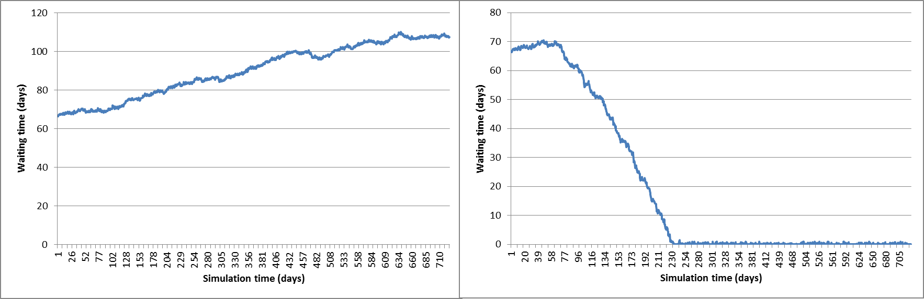Figure 1 The change in individual patient waiting times over the course of the simulation (left: baseline scenario, right: DECODE experimental scenario 9)

Assessment numbers
The impact of DECODE on referral, assessment and diagnosis numbers for scenarios 1 and 9 in comparison to the base line scenario are shown in Table 2. There is an increase in the total number of diagnoses made, the number of patients receiving no diagnosis and the overall number of referrals dealt with. The number of assessments undertaken decreases overall and the number of no diagnosis outcomes by assessment reduces most dramatically by over 81%.
Table 2 Diagnosis, assessment and referral numbers for the baseline and DECODE scenarios
 | Baseline | DECODE Scenario 1 |  |  | DECODE Scenario 9
 | Baseline values | DECODE values | Difference | % difference | DECODE values | Difference | % difference
Total diagnoses | 892 | 1004 | 112.35 | 13% | 955 | 62.76 | 7%
Total no diagnosis by assessment | 749 | 254 | -495.09 | -66% | 140 | -609.63 | -81%
Total no diagnosis by triage | 0 | 615 | 614.94 | 100% | 779 | 779.40 | 100%
Total no diagnosis | 749 | 869 | 119.85 | 16% | 919 | 169.78 | 23%
Total referrals dealt with | 1641 | 1873 | 232.20 | 14% | 1874 | 232.53 | 14%
Total assessments undertaken | 1641 | 1258 | -382.74 | -23% | 1094 | -546.87 | -33%

The decrease in the number of assessments undertaken leads to a decrease in resource utilisation (staff members undertaking assessments) from 100% utilisation at baseline to between 67% and 77%.

False negatives
In the scenarios tested in the model the number of false negatives produced by the DECODE system are between 0.68% in scenario 1 (6 people per year) and 3.33% in scenario 9 (31 people per year) of the total number of referrals dealt with. Reducing the cut point for the DECODE triage process reduces the number of false negatives produced; the impact of changing the cut point for triage on false negatives and resource utilisation are show in Figure 2.
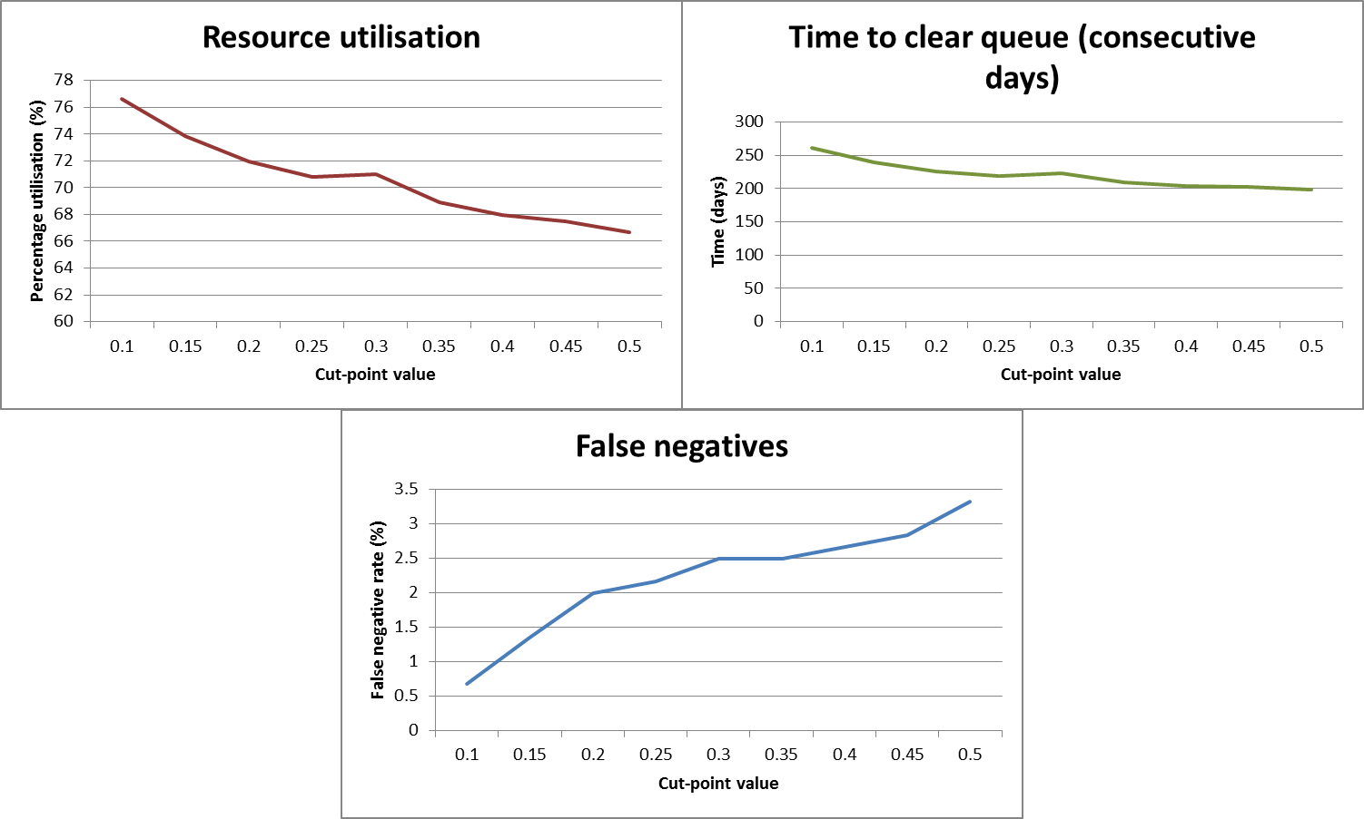
Figure 2 Top left: resource utilisation; top right: time taken for the queue to be cleared; bottom centre: false negative rate as a percentage of the total referrals handled.
From a cut point of 0.25 or less the number of false negatives are less than 2.5% of the total referrals dealt with. For cut points of between 0.25 and 0.1 resource utilisation is decreased to between 71% and 77% respectively. This demonstrates that even if the risk of false negatives is mitigated to its maximum extent (0.1 cut point) large resource capacity savings can be achieved and Figure 2 also shows that a waiting lime of less than one day can be achieved at any cut-point level of 0.1 or above but the lower the cut-point the more time it will take for the queue to be cleared.

Implications
The DECODE triage app can be used to reduce the waiting times at the Exeter memory clinic and additional capacity will be released from the system. When DECODE is implemented it will take approximately 61 consecutive days for there to be a measurable reduction in waiting times and it could then take between 200 and 250 consecutive days until the minimum waiting time is reached depending on the cut point used for triaging patients.

